# How To Broadcast Your First Live Stream On Joomla With Hapity

In this article, you'll learn how to create your first Hapity live broadcast on your Joomla site with simple step-by-step instructions. After just a few minutes, you'll have a working live stream that your visitors can watch.

[embed video version of this here]

## Step 1: Create Your Free Hapity Account

To get started, create your free Hapity account. [Go to the registration page](https://www.hapity.com/register) and enter your desired login credentials. Or, you can also sign in with Facebook or Twitter:

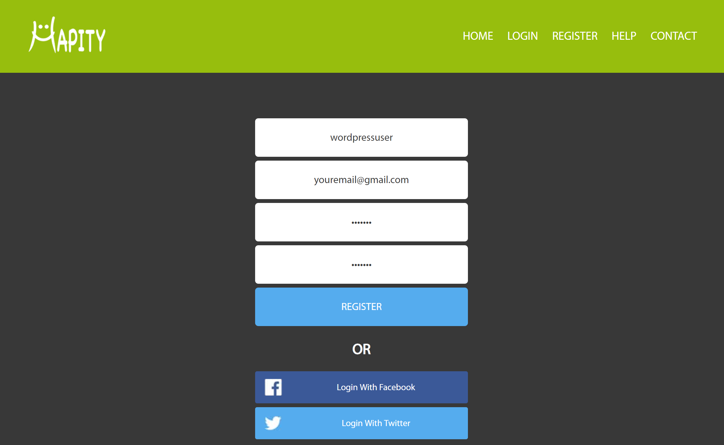

WordPress-1

In order to connect your Hapity account to your Joomla site, you'll use something called an "Auth ID" to link the two together.

To find your Auth ID, [log in to your Hapity account](https://www.hapity.com/home/login) and click on **Settings** in the top-right corner:

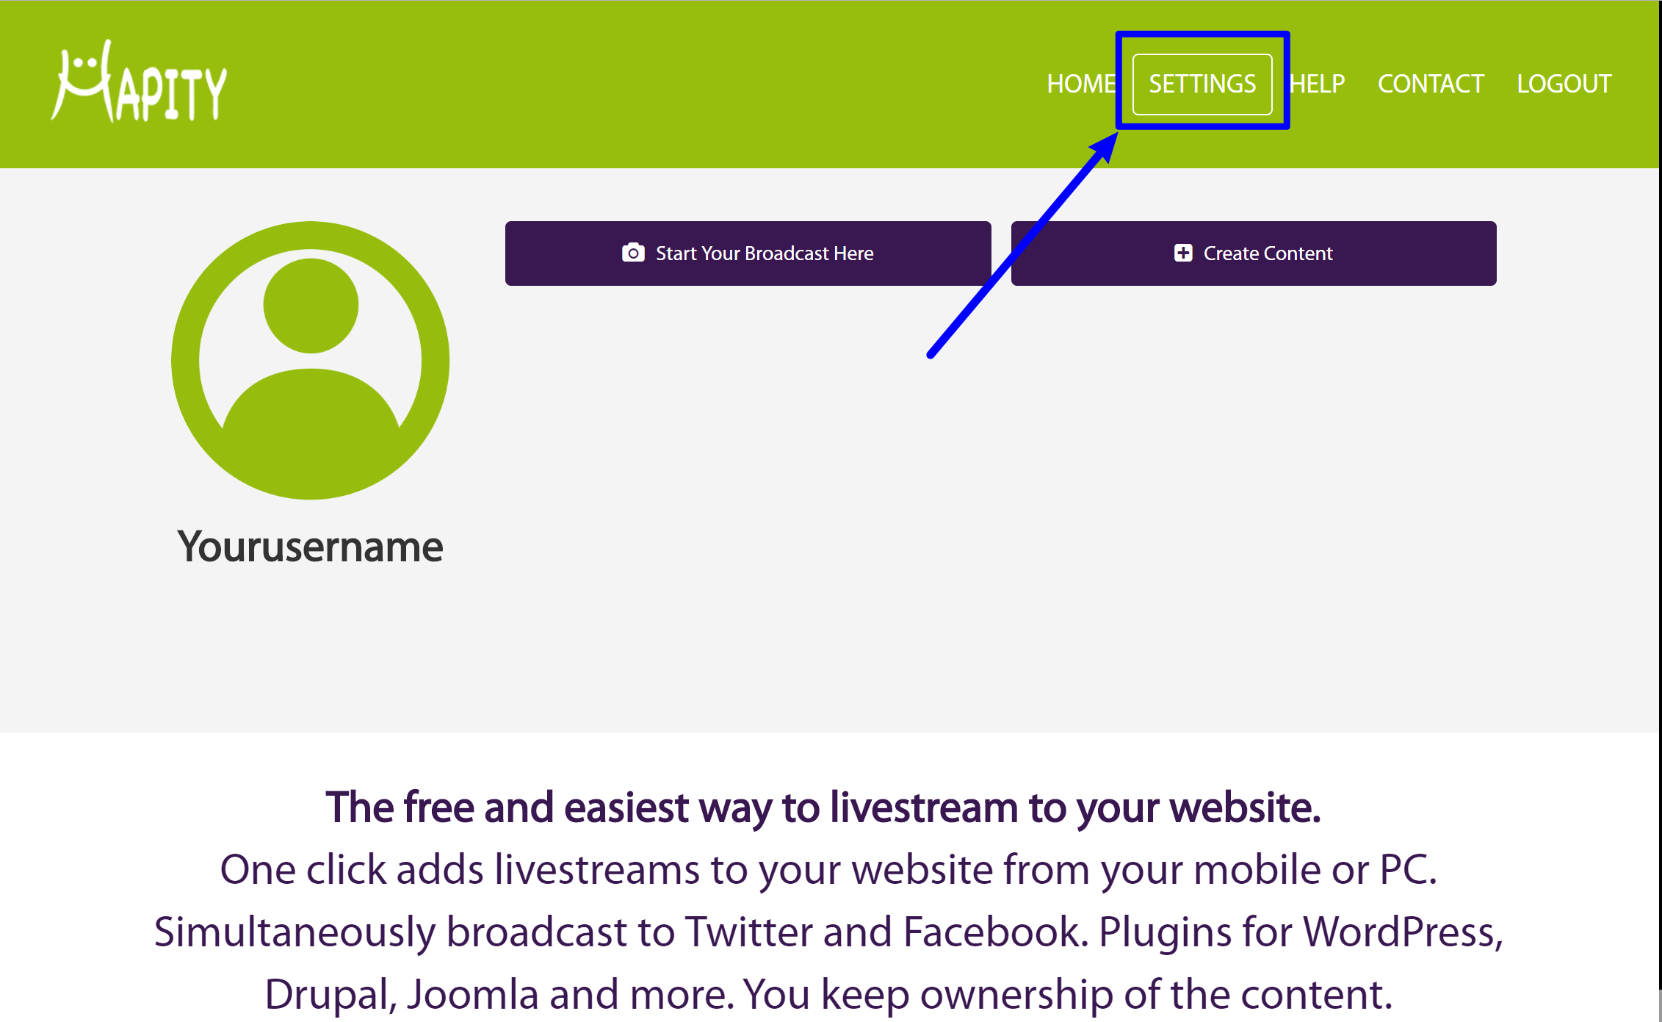

WordPress-4

Then, scroll down and find the box for **Plugin ID**, which contains a long string of numbers and letters. Copy the value in this box:

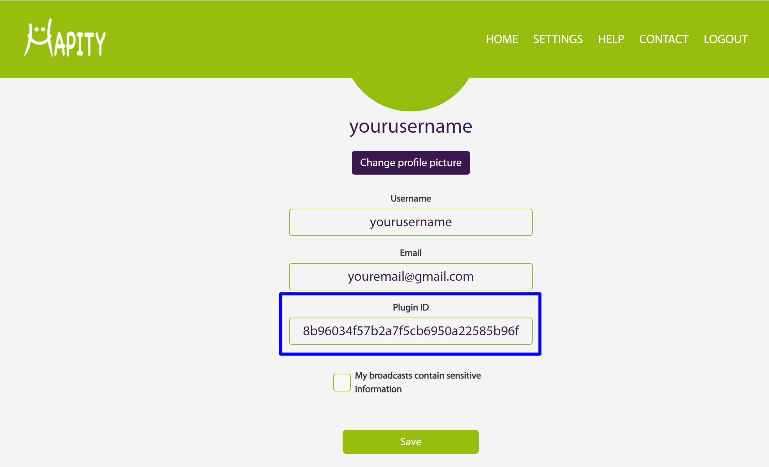

WordPress-5

Make a note of this as we’ll need it in a moment.

## Step 2: Install And Activate The Free Hapity Module

Download the Hapity Joomla module [from the Hapity website](https://www.hapity.com/help), and unzip this. Use FTP to navigate to: [Joomla root]/components/ . Then, upload the unzipped module.

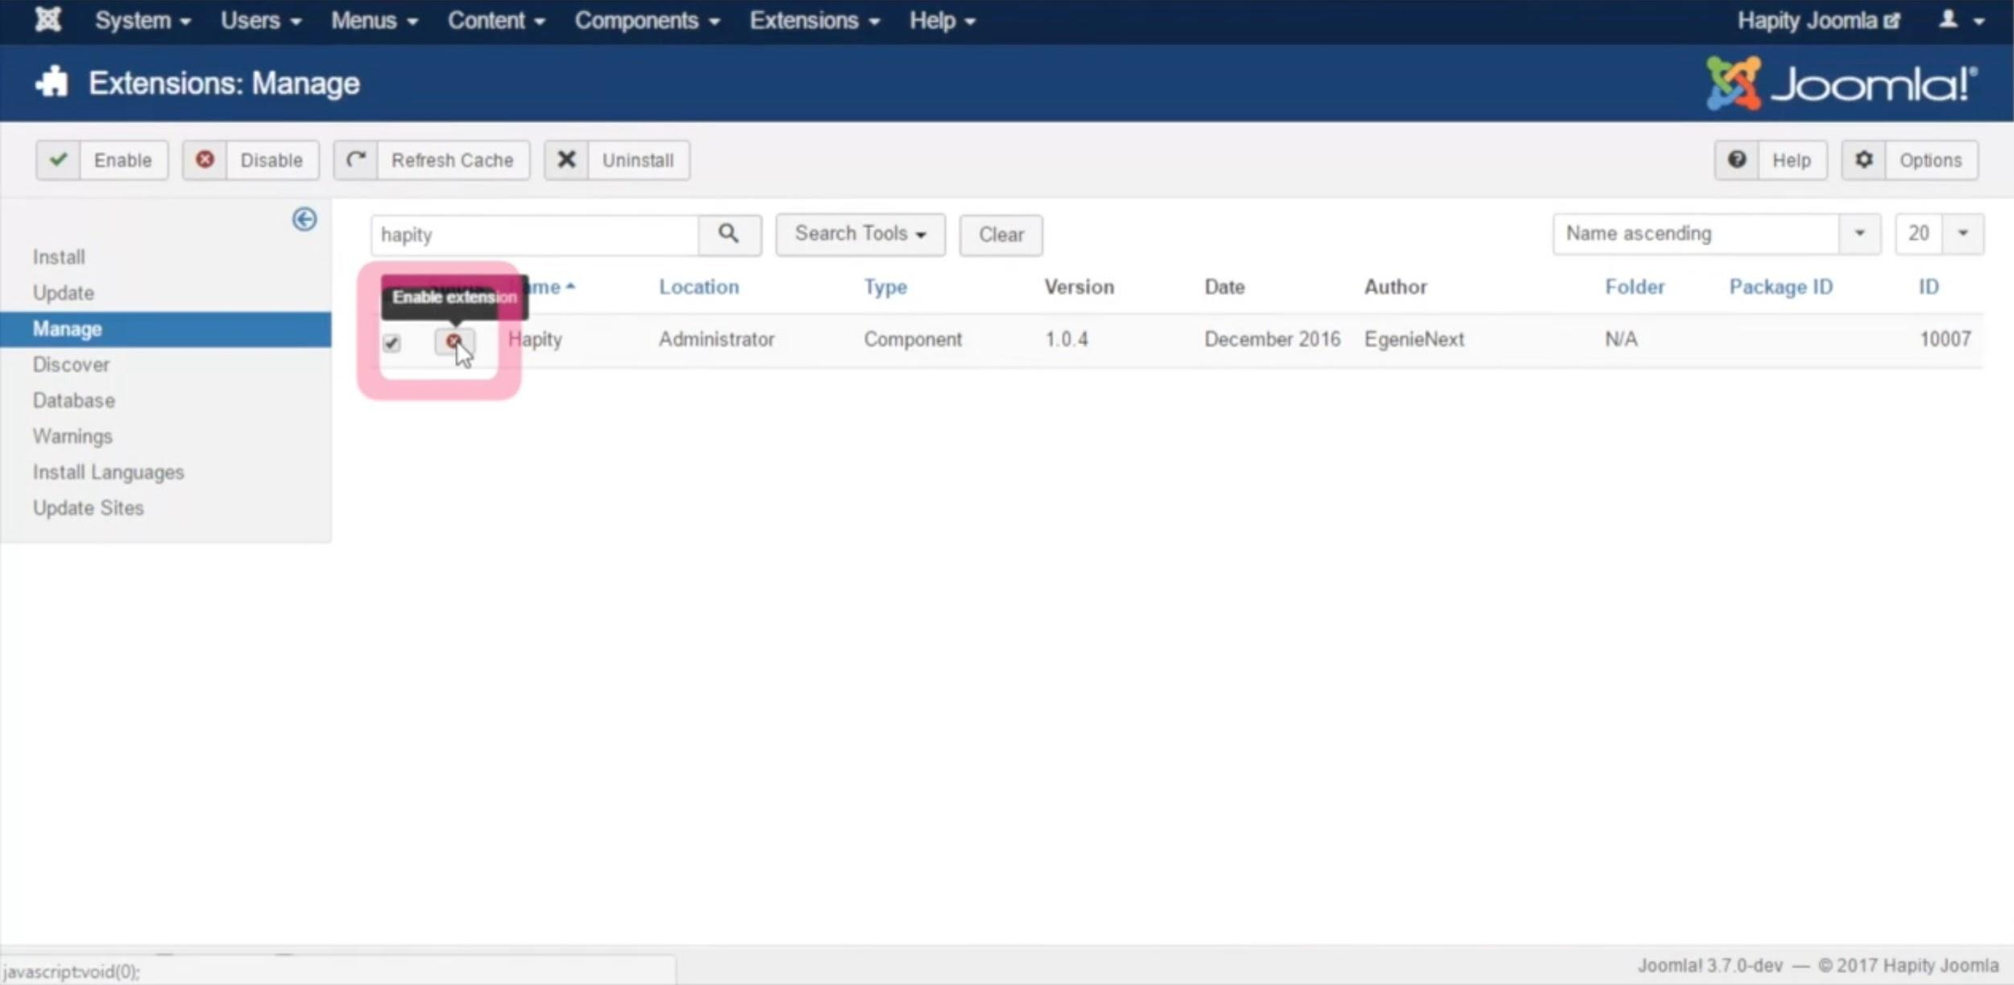

Joomla-1

Login to your Joomla admin panel, and click Install Extensions. Click on Manage, and find Hapity in the list of modules. Enable this.

## Step 3: Add Hapity Auth ID To Plugin

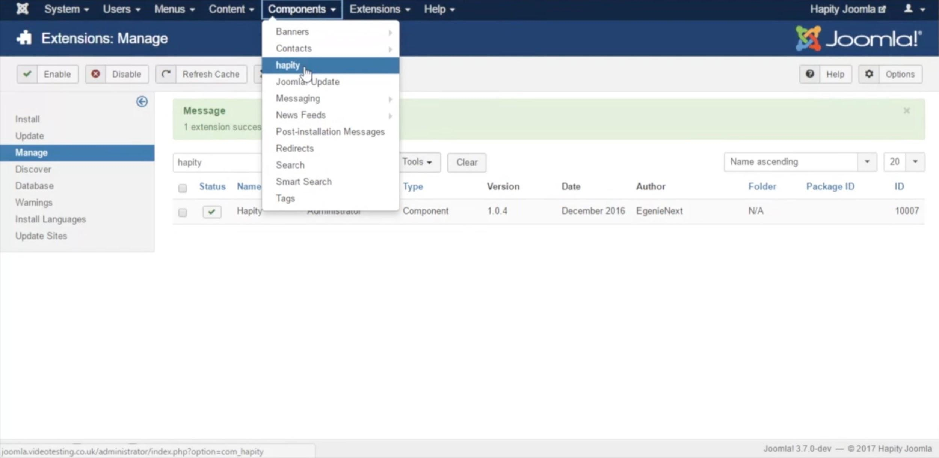

Joomla-2

From the Components menu select Hapity, and paste in the ID gathered at Step 1 into the Hapity Plugin’s ID, and save this.

## Step 4: Broadcast Your First Live Stream

Now you're ready to broadcast your first live stream!

With Hapity, you can broadcast from your:

* Mobile device (iOS or Android)
* Computer

You can share your broadcast before or after on Twitter and Facebook by selecting the appropriate icons; the first time you use these, you’ll be asked to log in. You can also share on other platforms including email, SMS, and Whatsapp.

If using a mobile device, your broadcast will be saved onto this device (find this under Gallery on Android, and Photos on iPhone).

The livestream and data are handled by Hapity servers, so there’s no need to worry about any additional charges for your website hosting. You own all the content you livestream.

### Broadcasting from a mobile device

To broadcast from your mobile device, you'll first need to install the Hapity app from the [Google Play Store (Android devices)](https://play.google.com/store/apps/details?id=com.app.hapity) or [Apple's App Store (iOS devices)](https://itunes.apple.com/jm/app/hapity/id1068976447?mt=8).

When you first open the app, you'll need to sign into your Hapity account. Then, you can click the floating camera icon in the bottom-right corner to start your first broadcast:

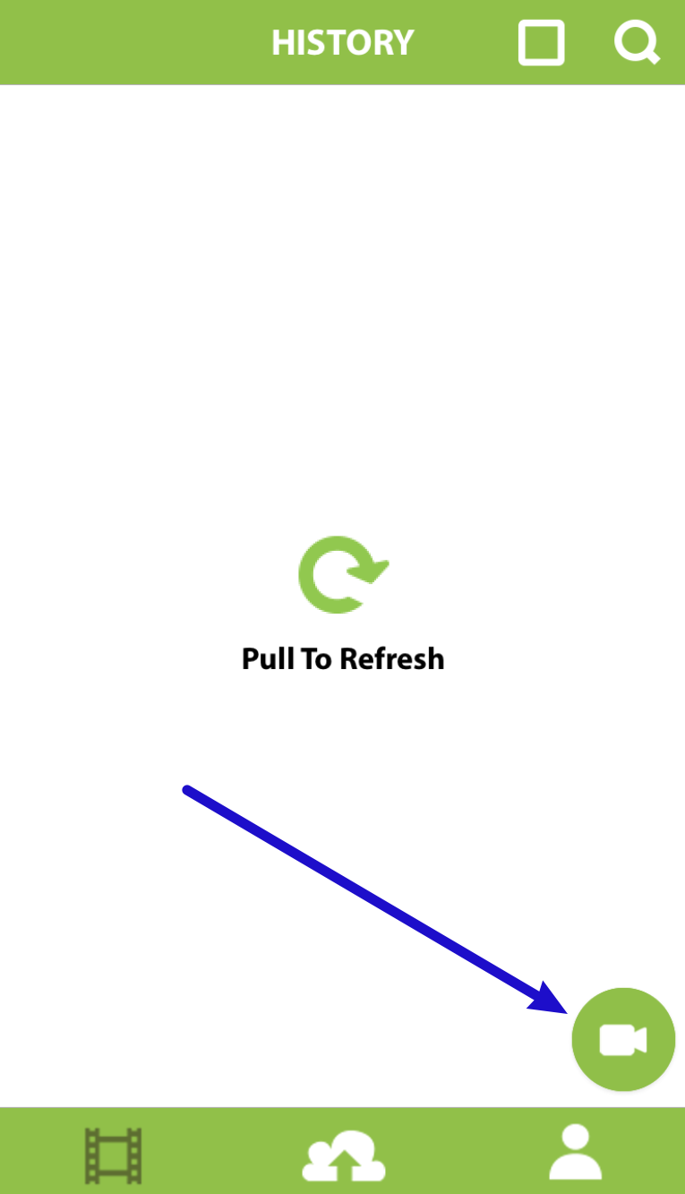

Mobile-1

After clicking that button, you'll need to give Hapity permission to access your device's:

* Camera
* Microphone
* Pictures

*These permissions are necessary to create a broadcast and save the broadcast video to your device.*

Then, you should see the video feed from your device on your screen.

You can give your broadcast a name by typing in the text field. Then, just click the green circle when you're ready to make your broadcast live and available to the public:

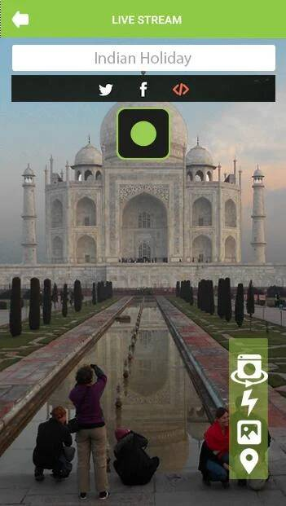

Mobile-2

Once you go live, you'll see a "You Are Live Now" indicator in the bottom-left corner of your screen.

And when you're ready to end your broadcast, all you need to do is click the red circle in the middle of your screen.

### Broadcasting from your computer

If your computer has a web camera, you can live stream straight from the Hapity website. To do that, [log in to your Hapity account](https://www.hapity.com/home/login). Then, click the **Start Your Broadcast Here** button:

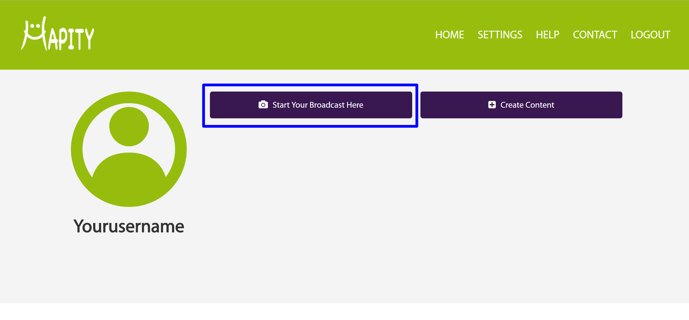

WordPress-8

Before you begin, you can give your broadcast an optional name and configure some other basic options. If you want to automatically add your live stream to your Drupal website, you should check the box for **Embed into website**.

If you’re using the Chrome web browser and need to enable Flash, follow these instructions. [**link other doc].**

When you're ready to begin your broadcast, click the **Start** button:

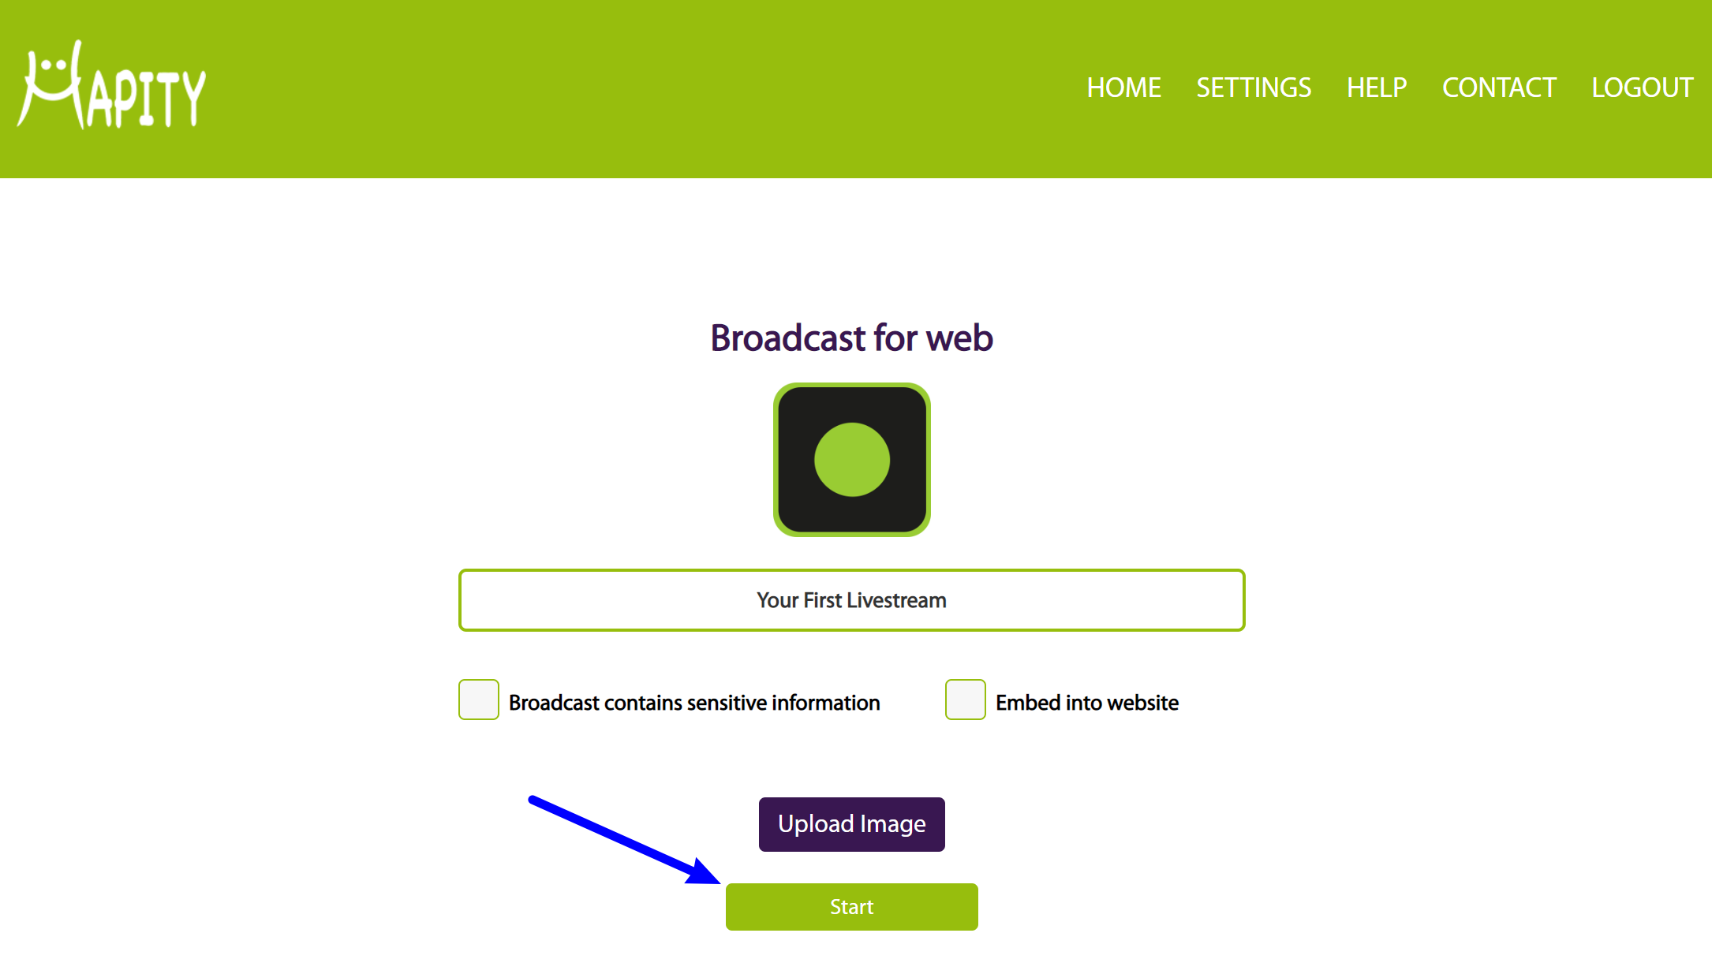

WordPress-9

Then, you'll see a prompt to give Hapity access to your computer's camera and microphone, which is necessary in order for Hapity to broadcast your content:

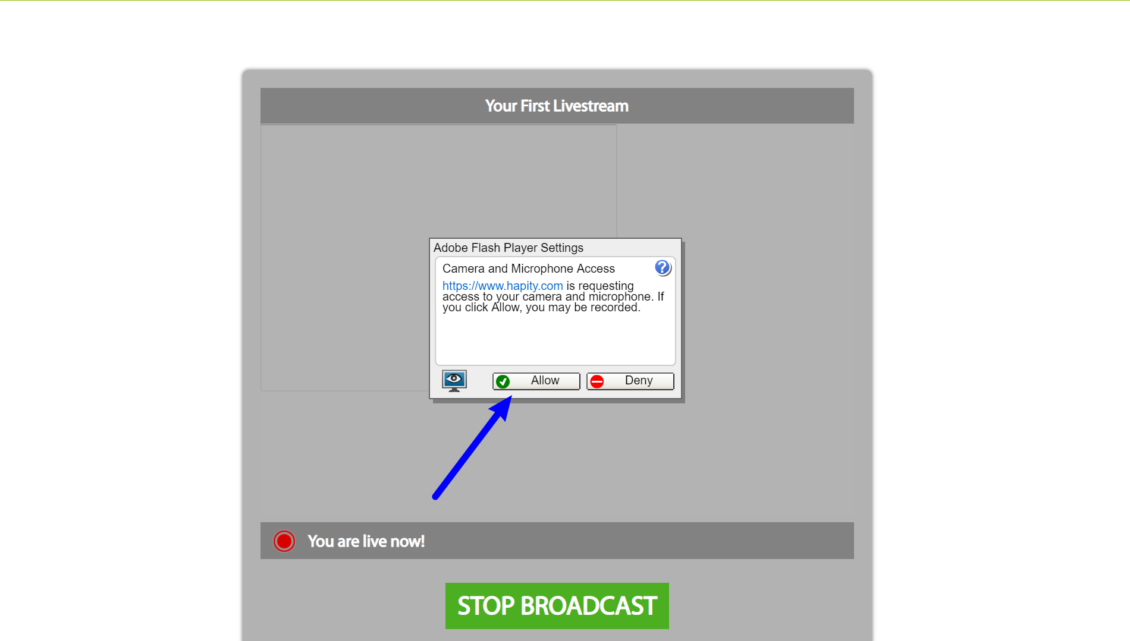

WordPress-10

Once you allow Hapity to have access to your camera and microphone, your broadcast is live. Say hello to your audience and have some fun!

You'll also see a live video feed of your broadcast, so you'll always know exactly what your visitors are seeing.

Your broadcast will be automatically posted to your Joomla site. Congratulations! You’ve just created your first live broadcast with Hapity.